**PHOENIX LANGAMAN**

125 Peralta St. Brgy. Consule Sur San Marcelino Zambales

Light Residences Boni Station Mandaluyong

Madison St., Mandaluyong City

To whom it may concern,

May I request that my security deposit refund be transferred to my account with the following details:

Bank: **BDO**

AccountName: **Phoenix Langaman**

AccountNumber **: 000440620058**

Attached to my email is the image of my TIN ID together with this letter of request. For any concerns, you may contact me at **091715513030.**

Best Regards,

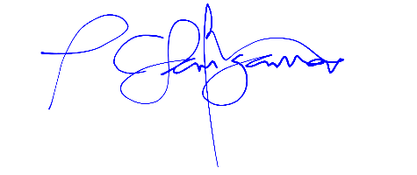

**Phoenix Langaman**

125 Peralta St. Brgy. Consule Sur San Marcelino Zambales